Siddhanta Shiromani
Grahaganit adhyaya
Madhyamaadhikare Kakshapakramah
(Section I, Chapter 4 : About the orbits)

Verse No | Translations
1 | The astronomers have determined the circumference of the sky to be 18,712,069,200,000,000 Yojanas. Some say this is the area enclosed by the two hemispheres of the universe. Some men experts in the branch of Puranas say that this is the area of the Lokaaloka mountain.
2 | Those who are learned in the science of spheres, and those who know the spheres like the emblic myrobalan (Aamlaka/Aamlaa) placed on their palm, tell us that the above mentioned figure signifies the distance of the universe which the rays of the sun traverses.
3 | If this be the area of the universe or not we know not. We think the above figure signifies the distance a planet travels eastwards in an Aeon. For this reason we name the above figure as the Khakaksha.
4 | If we divide the Khakaksha of a planet by the number of its revolutions in an Aeon we will have its orbit. The planet goes round its orbit many times before it completes the distance of Khakaksha.  Bimala Prasada Siddhanta Saraswati’s Note :  Khakaksha = Planetary Orbit x Number of planetary revolutions in an Aeon
5 | The mathematicians have determined that the orbits of the sun are 4,331,493.5 Yojanas, the orbit of the moon is 324,000 Yojanas and the orbit of the constellations is 25,988,985 Yojanas. The Agama book says that the orbit of the constellations is 60 times that of the orbit of the sun; it is for this reason that such measure is mentioned here.
6 | If we divide the Khakaksha with the total number of civil days in an Aeon we get the daily motion of the planet in Yojanas. Each day each of the planets travel 11,858.75 Yojanas.  Bimala Prasada Siddhanta Saraswati’s Note :  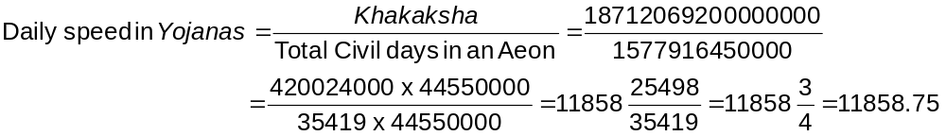

Verse No | Translations
7 | If we multiply the Aharganas by 9,921 and divide the product by 35,419 we will have a result. If this result be subtracted from 11,859 times Aharganas we will have the distance covered in Yojanas from the beginning of the Aeon.  Bimala Prasada Siddhanta Saraswati’s Note :  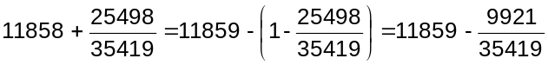
8 | If the above distance in Yojanas (i.e. Khakaksha) be divided individually by the own orbits of the planets we will have their individual mean revolution. Like while determining the planetary orbit, consider that the zenith and the node of a planet has their own separate orbits. (Separate orbit does not exist for the zenith. It is situated in the orbit of the planet and its orbit is only considered for simplifying our calculations.  Bimala Prasada Siddhanta Saraswati’s Note :  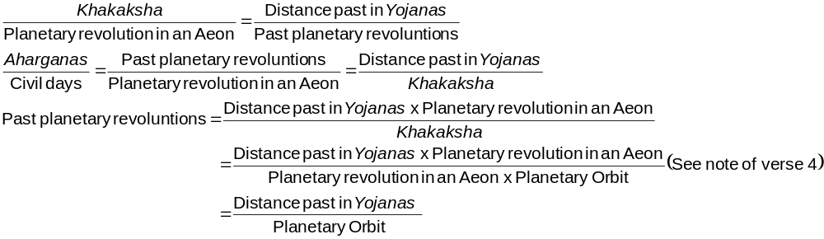
9 | The orbits of Mercury and Venus follow the same rule as that of the sun for finding out the mean of the orbit. Infact the travel on the orbit of their apex of fastest motion, and while doing so they travel at he speed of the sun.
Hence ends the chapter named Madhyamaadhikare Kakshapakramah
of Grahaganita part of Siddhanta Shiromani

Mythology. But some believe that Puranas are some form of written ancient history.

